Term Project of Yiğit Güler

Yiğit Güler

08 06 2021

library(car)

## Loading required package: carData

library(rmarkdown)  
library(haven)  
library(effects)

## Registered S3 methods overwritten by 'lme4':  
## method from  
## cooks.distance.influence.merMod car   
## influence.merMod car   
## dfbeta.influence.merMod car   
## dfbetas.influence.merMod car

## lattice theme set by effectsTheme()  
## See ?effectsTheme for details.

library(dplyr)

## Warning: package 'dplyr' was built under R version 4.0.4

##   
## Attaching package: 'dplyr'

## The following object is masked from 'package:car':  
##   
## recode

## The following objects are masked from 'package:stats':  
##   
## filter, lag

## The following objects are masked from 'package:base':  
##   
## intersect, setdiff, setequal, union

ceosal <- read_dta("ceosal.DTA")  
  
summary(ceosal)

## salary pcsalary sales roe   
## Min. : 223 Min. :-61.00 Min. : 175.2 Min. : 0.50   
## 1st Qu.: 736 1st Qu.: -1.00 1st Qu.: 2210.3 1st Qu.:12.40   
## Median : 1039 Median : 9.00 Median : 3705.2 Median :15.50   
## Mean : 1281 Mean : 13.28 Mean : 6923.8 Mean :17.18   
## 3rd Qu.: 1407 3rd Qu.: 20.00 3rd Qu.: 7177.0 3rd Qu.:20.00   
## Max. :14822 Max. :212.00 Max. :97649.9 Max. :56.30   
## pcroe ros indus finance   
## Min. :-98.9 Min. :-58.0 Min. :0.0000 Min. :0.0000   
## 1st Qu.:-21.2 1st Qu.: 21.0 1st Qu.:0.0000 1st Qu.:0.0000   
## Median : -3.0 Median : 52.0 Median :0.0000 Median :0.0000   
## Mean : 10.8 Mean : 61.8 Mean :0.3206 Mean :0.2201   
## 3rd Qu.: 19.5 3rd Qu.: 81.0 3rd Qu.:1.0000 3rd Qu.:0.0000   
## Max. :977.0 Max. :418.0 Max. :1.0000 Max. :1.0000   
## consprod utility lsalary lsales   
## Min. :0.0000 Min. :0.0000 Min. :5.407 Min. : 5.166   
## 1st Qu.:0.0000 1st Qu.:0.0000 1st Qu.:6.601 1st Qu.: 7.701   
## Median :0.0000 Median :0.0000 Median :6.946 Median : 8.217   
## Mean :0.2871 Mean :0.1722 Mean :6.950 Mean : 8.292   
## 3rd Qu.:1.0000 3rd Qu.:0.0000 3rd Qu.:7.249 3rd Qu.: 8.879   
## Max. :1.0000 Max. :1.0000 Max. :9.604 Max. :11.489

1. We have lower p-value than our threshold so we accept the the null hypothesis in our model **ros** is not significant and can be accepted as zero.

reg.ceo <- lm(lsalary ~ lsales + roe + ros, data = ceosal)  
reg.ceo

##   
## Call:  
## lm(formula = lsalary ~ lsales + roe + ros, data = ceosal)  
##   
## Coefficients:  
## (Intercept) lsales roe ros   
## 4.3117125 0.2803149 0.0174168 0.0002417

summary(reg.ceo)

##   
## Call:  
## lm(formula = lsalary ~ lsales + roe + ros, data = ceosal)  
##   
## Residuals:  
## Min 1Q Median 3Q Max   
## -0.96060 -0.27144 -0.03264 0.22563 2.79805   
##   
## Coefficients:  
## Estimate Std. Error t value Pr(>|t|)   
## (Intercept) 4.3117125 0.3154329 13.669 < 2e-16 ***  
## lsales 0.2803149 0.0353200 7.936 1.34e-13 ***  
## roe 0.0174168 0.0040923 4.256 3.17e-05 ***  
## ros 0.0002417 0.0005418 0.446 0.656   
## ---  
## Signif. codes: 0 '***' 0.001 '**' 0.01 '*' 0.05 '.' 0.1 ' ' 1  
##   
## Residual standard error: 0.4832 on 205 degrees of freedom  
## Multiple R-squared: 0.2827, Adjusted R-squared: 0.2722   
## F-statistic: 26.93 on 3 and 205 DF, p-value: 1.001e-14

1. We have 4 variables showing the industry of the companies which are showed with 0 and 1.

summary(ceosal)

## salary pcsalary sales roe   
## Min. : 223 Min. :-61.00 Min. : 175.2 Min. : 0.50   
## 1st Qu.: 736 1st Qu.: -1.00 1st Qu.: 2210.3 1st Qu.:12.40   
## Median : 1039 Median : 9.00 Median : 3705.2 Median :15.50   
## Mean : 1281 Mean : 13.28 Mean : 6923.8 Mean :17.18   
## 3rd Qu.: 1407 3rd Qu.: 20.00 3rd Qu.: 7177.0 3rd Qu.:20.00   
## Max. :14822 Max. :212.00 Max. :97649.9 Max. :56.30   
## pcroe ros indus finance   
## Min. :-98.9 Min. :-58.0 Min. :0.0000 Min. :0.0000   
## 1st Qu.:-21.2 1st Qu.: 21.0 1st Qu.:0.0000 1st Qu.:0.0000   
## Median : -3.0 Median : 52.0 Median :0.0000 Median :0.0000   
## Mean : 10.8 Mean : 61.8 Mean :0.3206 Mean :0.2201   
## 3rd Qu.: 19.5 3rd Qu.: 81.0 3rd Qu.:1.0000 3rd Qu.:0.0000   
## Max. :977.0 Max. :418.0 Max. :1.0000 Max. :1.0000   
## consprod utility lsalary lsales   
## Min. :0.0000 Min. :0.0000 Min. :5.407 Min. : 5.166   
## 1st Qu.:0.0000 1st Qu.:0.0000 1st Qu.:6.601 1st Qu.: 7.701   
## Median :0.0000 Median :0.0000 Median :6.946 Median : 8.217   
## Mean :0.2871 Mean :0.1722 Mean :6.950 Mean : 8.292   
## 3rd Qu.:1.0000 3rd Qu.:0.0000 3rd Qu.:7.249 3rd Qu.: 8.879   
## Max. :1.0000 Max. :1.0000 Max. :9.604 Max. :11.489

pairs(ceosal)

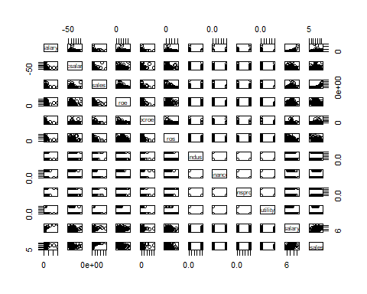

glimpse(ceosal)

## Rows: 209  
## Columns: 12  
## $ salary <dbl> 1095, 1001, 1122, 578, 1368, 1145, 1078, 1094, 1237, 833, ...  
## $ pcsalary <dbl> 20, 32, 9, -9, 7, 5, 10, 7, 16, 5, 7, -3, -9, 9, 49, 4, 12...  
## $ sales <dbl> 27595.0, 9958.0, 6125.9, 16246.0, 21783.2, 6021.4, 2266.7,...  
## $ roe <dbl> 14.1, 10.9, 23.5, 5.9, 13.8, 20.0, 16.4, 16.3, 10.5, 26.3,...  
## $ pcroe <dbl> 106.4, -30.6, -16.3, -25.7, -3.0, 1.0, -5.9, -1.6, -70.2, ...  
## $ ros <dbl> 191, 13, 14, -21, 56, 55, 62, 44, 37, 37, 109, -10, 41, 44...  
## $ indus <dbl> 1, 1, 1, 1, 1, 1, 1, 1, 1, 1, 1, 1, 1, 1, 1, 1, 1, 1, 1, 1...  
## $ finance <dbl> 0, 0, 0, 0, 0, 0, 0, 0, 0, 0, 0, 0, 0, 0, 0, 0, 0, 0, 0, 0...  
## $ consprod <dbl> 0, 0, 0, 0, 0, 0, 0, 0, 0, 0, 0, 0, 0, 0, 0, 0, 0, 0, 0, 0...  
## $ utility <dbl> 0, 0, 0, 0, 0, 0, 0, 0, 0, 0, 0, 0, 0, 0, 0, 0, 0, 0, 0, 0...  
## $ lsalary <dbl> 6.998509, 6.908755, 7.022868, 6.359574, 7.221105, 7.043160...  
## $ lsales <dbl> 10.225389, 9.206132, 8.720281, 9.695602, 9.988894, 8.70307...

1. If we look at the F-stat we can say that our model is significant with 205 degrees of freedom. The Coefficients are significant except **ros**. Adjusted R-squared is 0.2722. That means we can explain %27,22 of the model.

summary(reg.ceo)

##   
## Call:  
## lm(formula = lsalary ~ lsales + roe + ros, data = ceosal)  
##   
## Residuals:  
## Min 1Q Median 3Q Max   
## -0.96060 -0.27144 -0.03264 0.22563 2.79805   
##   
## Coefficients:  
## Estimate Std. Error t value Pr(>|t|)   
## (Intercept) 4.3117125 0.3154329 13.669 < 2e-16 ***  
## lsales 0.2803149 0.0353200 7.936 1.34e-13 ***  
## roe 0.0174168 0.0040923 4.256 3.17e-05 ***  
## ros 0.0002417 0.0005418 0.446 0.656   
## ---  
## Signif. codes: 0 '***' 0.001 '**' 0.01 '*' 0.05 '.' 0.1 ' ' 1  
##   
## Residual standard error: 0.4832 on 205 degrees of freedom  
## Multiple R-squared: 0.2827, Adjusted R-squared: 0.2722   
## F-statistic: 26.93 on 3 and 205 DF, p-value: 1.001e-14

salvars <- coef(reg.ceo)  
salvars

## (Intercept) lsales roe ros   
## 4.3117124632 0.2803148895 0.0174167522 0.0002416552

cor.data <- cor(ceosal[,c(4,6,11,12)])  
print(cor.data)

## roe ros lsalary lsales  
## roe 1.0000000 0.27491881 0.20849920 -0.1225531  
## ros 0.2749188 1.00000000 -0.07456453 -0.3503296  
## lsalary 0.2084992 -0.07456453 1.00000000 0.4591482  
## lsales -0.1225531 -0.35032965 0.45914817 1.0000000

1. We can observe that **ros** and **lsalary**, does not neccesarly have a correlation.

scatterplotMatrix(~ lsalary + lsales + roe + ros, data = ceosal)

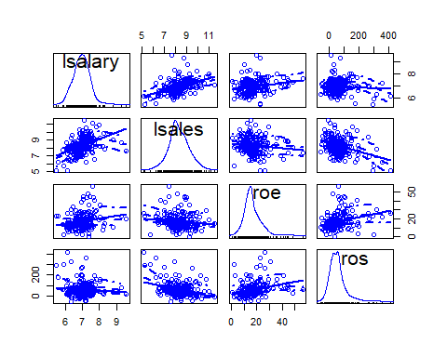

1. Below we can see how the variables placed in our model we can see that **ros** is behaving differently than the others. Our estimation with the variables are not so different than the actual data. The outlier effects is not too heavy to bear.

residualPlots(reg.ceo)

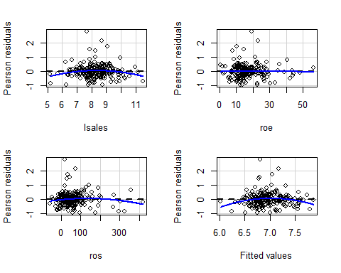

## Test stat Pr(>|Test stat|)   
## lsales -2.2358 0.026451 *   
## roe -0.2604 0.794824   
## ros -1.4548 0.147249   
## Tukey test -2.7005 0.006923 **  
## ---  
## Signif. codes: 0 '***' 0.001 '**' 0.01 '*' 0.05 '.' 0.1 ' ' 1

marginalModelPlots(reg.ceo)

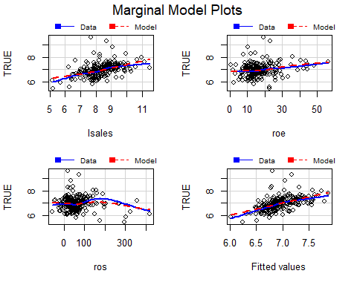

mcPlots(reg.ceo,~lsales + roe + ros, overlaid=FALSE)

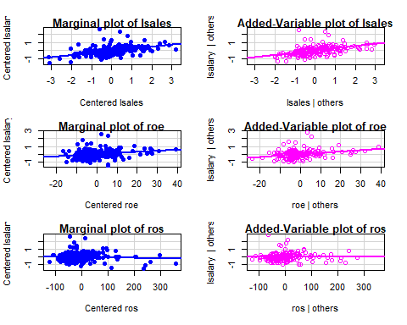

We see how well we can estimate the model with taken predictors.

plot(predictorEffects(reg.ceo))

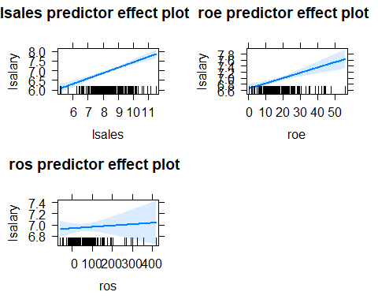

summary(reg.ceo)

##   
## Call:  
## lm(formula = lsalary ~ lsales + roe + ros, data = ceosal)  
##   
## Residuals:  
## Min 1Q Median 3Q Max   
## -0.96060 -0.27144 -0.03264 0.22563 2.79805   
##   
## Coefficients:  
## Estimate Std. Error t value Pr(>|t|)   
## (Intercept) 4.3117125 0.3154329 13.669 < 2e-16 ***  
## lsales 0.2803149 0.0353200 7.936 1.34e-13 ***  
## roe 0.0174168 0.0040923 4.256 3.17e-05 ***  
## ros 0.0002417 0.0005418 0.446 0.656   
## ---  
## Signif. codes: 0 '***' 0.001 '**' 0.01 '*' 0.05 '.' 0.1 ' ' 1  
##   
## Residual standard error: 0.4832 on 205 degrees of freedom  
## Multiple R-squared: 0.2827, Adjusted R-squared: 0.2722   
## F-statistic: 26.93 on 3 and 205 DF, p-value: 1.001e-14

plot(predictorEffects(reg.ceo))

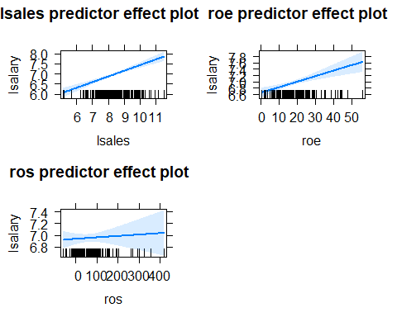

# Equation of the model

With using 3 predictors we come up with the model below. Using **reg.ceo**. The interpretaions and way of estimations are above.

$$E(log(salary))=β_{0}+ (lsales)x_{1}+ (roe)x_{2}+ (ros)x_{3}$$

$$E(log(salary))=4.3117125+ (lsales)0.2803149+ (roe)0.0174168+ (ros)0$$

1. Since ros is insignificant in our model it does not change the salary and we take it as zero. But 50 units in increase would result to 0.0002417*50 = 0.012085 Of course in the model we have log-level so 100*0.0002417x50 = 1.2085 per cent change It is not that big of a change considering it is also **insignificant**.
2. We can see that we conclude with cor = -0.0336819 at the given confidence intervals. In the light of the previous findings we can accept the Ho in this case. **ros** is not significant in our model. Ergo we cannot use it nor can say it has a positive effect on **salary**.

aa <- ceosal[,c(1,6)]  
  
cor.test(aa$salary,aa$ros, conf.level = 0.90)

##   
## Pearson's product-moment correlation  
##   
## data: aa$salary and aa$ros  
## t = -0.48487, df = 207, p-value = 0.6283  
## alternative hypothesis: true correlation is not equal to 0  
## 90 percent confidence interval:  
## -0.14721939 0.08073166  
## sample estimates:  
## cor   
## -0.0336819

cor.test(aa$salary,aa$ros, conf.level = 0.95)

##   
## Pearson's product-moment correlation  
##   
## data: aa$salary and aa$ros  
## t = -0.48487, df = 207, p-value = 0.6283  
## alternative hypothesis: true correlation is not equal to 0  
## 95 percent confidence interval:  
## -0.1686257 0.1025013  
## sample estimates:  
## cor   
## -0.0336819

cor.test(aa$salary,aa$ros, conf.level = 0.99)

##   
## Pearson's product-moment correlation  
##   
## data: aa$salary and aa$ros  
## t = -0.48487, df = 207, p-value = 0.6283  
## alternative hypothesis: true correlation is not equal to 0  
## 99 percent confidence interval:  
## -0.2099903 0.1447481  
## sample estimates:  
## cor   
## -0.0336819

1. No I would not because of the fact that given findings. There is no situation we can accept **ros** to explain compensation for the CEOs. Since we cannot accept it any model as a variable. The significancy of **ros** is making it impossible to include into our models. Ros predictor is not a good predictor.

reg.ceo <- lm(lsalary ~ lsales + roe + ros, data = ceosal)  
  
summary(reg.ceo)

##   
## Call:  
## lm(formula = lsalary ~ lsales + roe + ros, data = ceosal)  
##   
## Residuals:  
## Min 1Q Median 3Q Max   
## -0.96060 -0.27144 -0.03264 0.22563 2.79805   
##   
## Coefficients:  
## Estimate Std. Error t value Pr(>|t|)   
## (Intercept) 4.3117125 0.3154329 13.669 < 2e-16 ***  
## lsales 0.2803149 0.0353200 7.936 1.34e-13 ***  
## roe 0.0174168 0.0040923 4.256 3.17e-05 ***  
## ros 0.0002417 0.0005418 0.446 0.656   
## ---  
## Signif. codes: 0 '***' 0.001 '**' 0.01 '*' 0.05 '.' 0.1 ' ' 1  
##   
## Residual standard error: 0.4832 on 205 degrees of freedom  
## Multiple R-squared: 0.2827, Adjusted R-squared: 0.2722   
## F-statistic: 26.93 on 3 and 205 DF, p-value: 1.001e-14

pairs(ceosal)



# ros image

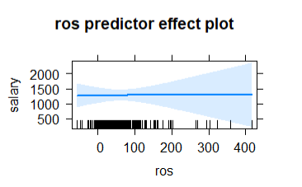

image